Chapter 10, Problem 49.

Using source transformation, find i in the circuit of Fig. 10.94.

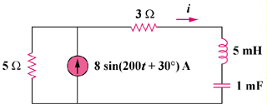

Figure 10.94
For Prob. 10.49.

